COURSE-ALIGNED STUDY HANDOUT | MATHEMATICS + THEORY + QUIZ PRACTICE

Slopes, Implicit Lines
and RGB–CMY–CMYK
Complete Computer Graphics notes with mathematical derivations, step-by-step calculations, visual examples, formula sheets, practice questions and instructor answers.
Teaching order: slope → line equation → implicit function → midpoint sign → RGB/CMY theory → numerical conversions → practice.

Learning outcomes
- Determine line slope and classify steep/shallow directions using signed dx, dy and |dx|, |dy|.
- Convert point-pair or slope–intercept equations into F(x,y) = ax + by + c = 0.
- Evaluate an implicit line function at a point and interpret its sign relative to the line.
- Explain additive RGB versus subtractive CMY/CMYK, including the role of black (K).
- Solve RGB-to-CMY and idealized RGB-to-CMYK calculations with units and correct rounding.

Source alignment: important distinction
COURSE MATERIAL: AIUB Chapter 1 – Image Representation, especially slides 15–27, covers additive/subtractive models, RGB, CMY and simple RGB-to-CMY conversions. The Chapter 2 Part 1 – Scan Conversion slides (especially 26–36) develop the implicit line equation used in midpoint line decisions.
SUPPLEMENTARY TEACHING EXTENSION: the full idealized RGB-to-CMYK percentage formulas, device/profile caveats, and extra worked problems are added here to support student understanding. They are not presented as formulas quoted from the original slides.

A quick map of the core formulas
Concept | Core relation
Slope | m = dy / dx; dx = x₂ − x₁, dy = y₂ − y₁
Implicit line | F(x,y) = dy(x − x₁) − dx(y − y₁)
RGB → CMY | C = 1 − R/255, M = 1 − G/255, Y = 1 − B/255
RGB → CMYK | K = 1 − max(Rₙ,Gₙ,Bₙ); divide remaining C,M,Y by 1 − K
CMYK → RGB | R = 255(1 − C)(1 − K); similarly G and B

1. Slope mathematics: what is shallow or steep?
For endpoints P₁=(x₁,y₁) and P₂=(x₂,y₂), horizontal displacement is dx=x₂−x₁ and vertical displacement is dy=y₂−y₁. Slope describes vertical change per unit horizontal change, provided dx ≠ 0.
m = (y₂ − y₁) / (x₂ − x₁) = dy / dx
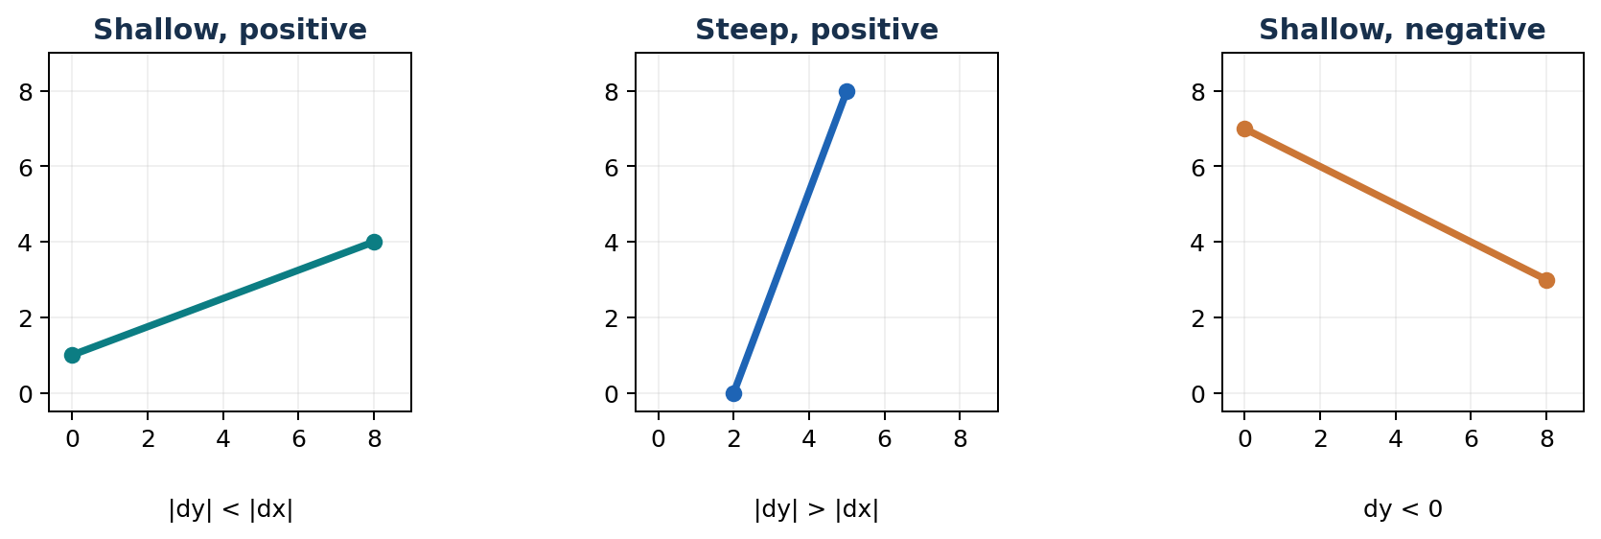
Classification | Test | Meaning
Shallow | |dy| < |dx| (|m| < 1) | x is the driving axis
Steep | |dy| > |dx| (|m| > 1) | y is the driving axis
45-degree magnitude | |dy| = |dx| | one unit on each axis
Horizontal | dy = 0; dx ≠ 0 | m = 0
Vertical | dx = 0 | m is undefined; use x = constant

Worked example A: shallow positive line
Endpoints (2,3) → (10,7): dx=10−2=8; dy=7−3=4. Since |4|<|8|, the line is shallow. Its slope is m=4/8=0.5.

Worked example B: steep positive line
Endpoints (3,2) → (5,10): dx=2; dy=8. Since |8|>|2|, it is steep. Slope m=8/2=4.

Worked example C: shallow negative line
Endpoints (1,8) → (7,5): dx=6; dy=−3, so m=−3/6=−0.5. It slopes down to the right, but is still shallow because |m|=0.5<1.
A negative slope is NOT automatically steep. Classification depends on the magnitude |m|, not whether m is positive or negative.

2. Implicit line equations: complete derivation
In Chapter 2, midpoint line rasterization is built from a sign test. To make that possible, rewrite the line equation so that the left side equals zero.

Method 1: slope–intercept form
y = mx + b
Substitute m=dy/dx (for dx≠0):
y = (dy/dx)x + b
Multiply by dx:
dx·y = dy·x + dx·b
Bring every term to the left:
dy·x − dx·y + dx·b = 0
Define a general line function:
F(x,y) = ax + by + c
For this particular choice of coefficients: a=dy, b_coefficient=−dx, c=dx·(y-intercept). The symbol b is used both for an intercept and sometimes a coefficient in different books—name them clearly to avoid confusion.

Method 2: endpoints only (recommended)
You do not need to find the y-intercept first. Let the line pass through (x₁,y₁):
F(x,y) = dy(x − x₁) − dx(y − y₁) = 0
Expand this endpoint form:
F(x,y) = dy·x − dx·y + (dx·y₁ − dy·x₁)
Thus a=dy, b=−dx, c=dx·y₁−dy·x₁. This method also handles vertical lines where slope is undefined.

What does the sign of F mean?
With the specific endpoint order dx>0 and F=dy(x−x₁)−dx(y−y₁), F>0 means the evaluated point is below the true line; F<0 means above it; F=0 means exactly on it.
The zero-set F=0 defines the line, but F’s positive/negative labels are NOT universal: swapping endpoint direction or multiplying F by a negative number flips its sign.

3. Implicit line: worked mathematics

Example 1: line through (2,3) and (10,7)
Step 1: dx = 10−2 = 8; dy = 7−3 = 4.
Step 2: substitute into the anchored implicit expression:
F(x,y) = 4(x−2) − 8(y−3)
= 4x − 8 − 8y + 24
= 4x − 8y + 16 = 0
Dividing by 4 gives x−2y+4=0; both equations describe exactly the same line. For sign comparisons below, keep the original positively scaled F=4x−8y+16.
Step 3: slope-intercept check: y=0.5x+2. For x=6, the true line passes through y=5.
Step 4: test the following points:
Point | Substitute into F = 4x − 8y + 16 | F | Position
(6,4) | 4(6)−8(4)+16 = 24−32+16 | +8 | Below
(6,5) | 4(6)−8(5)+16 = 24−40+16 | 0 | On line
(6,6) | 4(6)−8(6)+16 = 24−48+16 | −8 | Above

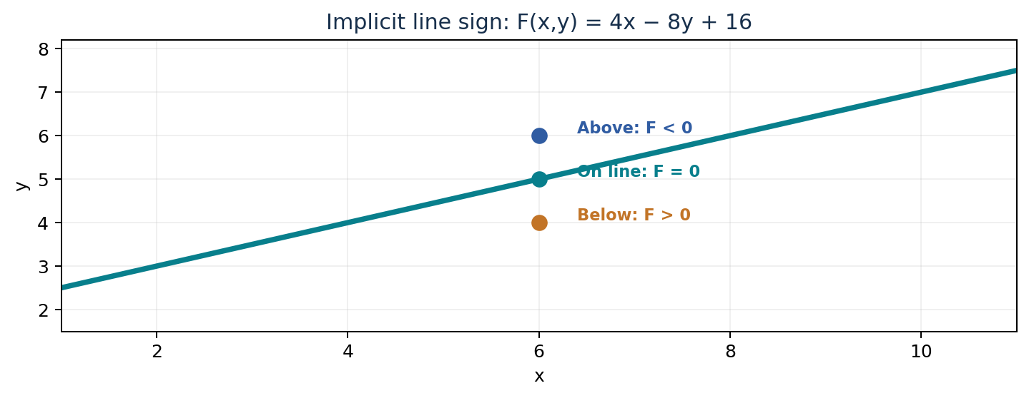

Connection to the Midpoint Line Algorithm
For a shallow positive line, the midpoint tested between E and NE is M=(x+1,y+0.5). If F(M)>0, the line is above that midpoint and NE is selected. If F(M)<0, E is selected. Your lecture uses E for the tie F(M)=0.

4. Additional implicit-line cases and common traps

Example 2: steep line through (3,2) and (5,10)
dx=2, dy=8, m=4 (steep). Use the endpoints:
F(x,y) = 8(x−3) − 2(y−2)
= 8x − 2y − 20 = 0
Check with y=4x−10: at x=3 → y=2, and x=5 → y=10. Both endpoints satisfy F=0.

Example 3: negative slope from (1,8) to (7,5)
dx=6, dy=−3, m=−0.5 (shallow).
F(x,y) = −3(x−1) − 6(y−8)
= −3x − 6y + 51 = 0
Divide the equation by −3: x+2y−17=0. This is the same geometric line, but the sign of the function changes because we multiplied by a negative factor.

Example 4: vertical line from (4,1) to (4,9)
dx=0; the slope formula would divide by zero, so the slope is undefined. The anchored form still works:
F(x,y) = 8(x−4) − 0(y−1) = 8x−32 = 0
x = 4

Why implicit form matters in computer graphics
- Midpoint line rasterization checks the sign of F(M) rather than solving y=mx+b repeatedly.
- The form ax+by+c=0 represents vertical lines without requiring infinite slope.
- It allows a compact decision parameter to be updated incrementally.
- The sign depends on the specific coefficients and direction of the line; always define your convention.
Exam shortcut: Calculate dx,dy → substitute in F=dy(x−x₁)−dx(y−y₁) → expand → verify both endpoints make F=0.

5. RGB colour model (additive mixing)
Your Chapter 1 slides present RGB as an additive model that controls red, green and blue light. Display screens form colours by combining emitted light. Each 8-bit RGB channel ranges from 0 to 255.
RGB = (R, G, B), where R,G,B ∈ {0,1,...,255}
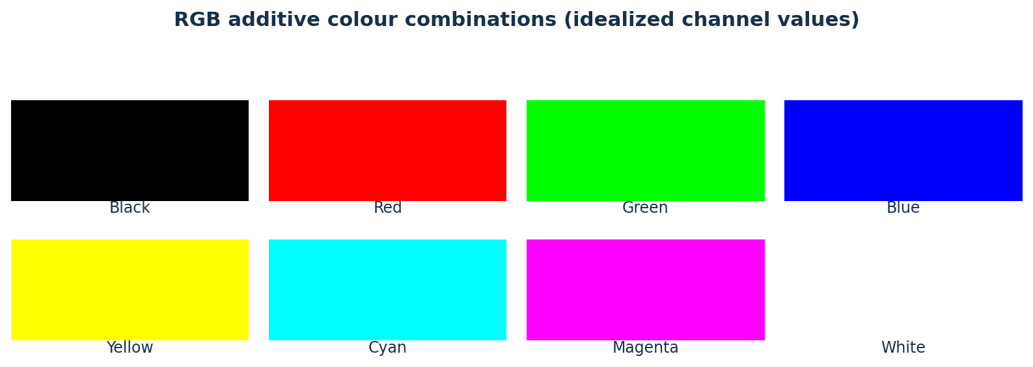
RGB (8-bit) | Ideal colour | Explanation
(0,0,0) | Black | No light from any channel
(255,255,255) | White | Maximum light from all three
(255,0,0) | Red | Red channel only
(255,255,0) | Yellow | Red + green
(0,255,255) | Cyan | Green + blue
(255,0,255) | Magenta | Red + blue

How many colours?
With 8 bits per channel, there are 256 intensity levels each for red, green and blue. Therefore 24-bit RGB has:
256 × 256 × 256 = 256³ = 16,777,216 colours
A 3-bit RGB palette with one on/off bit per channel yields 2³=8 combinations; two bits per channel (6-bit RGB) yields 4³=64 combinations, as introduced by the source slides.

Connection with OpenGL
In the classic course OpenGL interface, glColor3f(1.0, 0.0, 0.0) means full red; floating colour values in this call are normalized to 0–1, not 0–255.

6. CMY vs CMYK: subtractive colour
CMY stands for Cyan, Magenta and Yellow. On a white substrate, these colourants ideally subtract parts of the incoming light. The original Chapter 1 slides describe subtractive printing in contrast to RGB emitted light.
Channel | Ideal subtractive interpretation
Cyan (C) | Absorbs red light
Magenta (M) | Absorbs green light
Yellow (Y) | Absorbs blue light
Key / Black (K) | Additional black ink used in CMYK printing

Why is K added?
Mixing physical cyan, magenta and yellow inks does not reliably produce a deep neutral black. Separate black ink can improve dark detail, neutrality and printing efficiency. CMYK therefore has four channels.

Colour scales
RGB: each channel is commonly 0–255 (or 0–1 after normalization). CMY: three values from 0–1 (or 0–100%). CMYK: four values from 0–1 (or percentages).
Model | White (idealized) | Black (idealized) | Meaning
RGB 0–255 | (255,255,255) | (0,0,0) | Emitted light
CMY 0–1 | (0,0,0) | (1,1,1) | Ink amounts, idealized
CMYK 0–1 | (0,0,0,0) | (0,0,0,1) | Ink amounts; K alone for black

Colour model comparisons
Question | RGB | CMY/CMYK
Additive or subtractive? | Additive | Subtractive
Usually used for | Screens / display rendering | Printing / ink descriptions
White comes from | High RGB values | Paper with no ink
Black comes from | No emitted light | Black ink and/or heavy ink coverage
Standard channel units | 0–255 or 0–1 | 0–100% or 0–1

Important printing caveat: These formulas describe an idealized mathematical model. Accurate conversions for commercial printing require an appropriate colour profile, paper, inks and a colour-managed workflow.

7. RGB-to-CMY: source-aligned mathematical conversions
The next two formulas appear in your Chapter 1 teaching material (slides 26–27). CMY channels below are fractions in [0,1].

RGB → CMY
C = 1 − R/255
M = 1 − G/255
Y = 1 − B/255

Example A: RGB(64,128,192) → CMY
C = 1 − 64/255 = 191/255 ≈ 0.7490 = 74.90%
M = 1 − 128/255 = 127/255 ≈ 0.4980 = 49.80%
Y = 1 − 192/255 = 63/255 ≈ 0.2471 = 24.71%
Answer: CMY ≈ (74.90%, 49.80%, 24.71%)

CMY → RGB
R = 255(1 − C)
G = 255(1 − M)
B = 255(1 − Y)

Example B: CMY(20%,60%,10%) → RGB
First write percentages as fractions: C=.20, M=.60, Y=.10.
R=255(1−.20)=255(.80)=204
G=255(1−.60)=255(.40)=102
B=255(1−.10)=255(.90)=229.5 → 230 when rounding half upward
Answer: RGB ≈ (204,102,230)

Fast check: complement idea
If RGB red increases, cyan decreases, because C=1−R/255. Pure RGB red (255,0,0) converts to ideal CMY (0%,100%,100%).
In written problems, state rounding. This handout uses nearest integer for 8-bit RGB outputs, with .5 rounded up for nonnegative values.

8. RGB → CMYK: step-by-step mathematics
This section extends the lecture’s RGB/CMY complement idea with a standard idealized black-generation formula. It is presented for theoretical exercise, not colour-managed printing.

General procedure
Step 1 — normalize 8-bit RGB into the interval 0–1:
Rₙ=R/255, Gₙ=G/255, Bₙ=B/255
Step 2 — determine the fraction assigned to black:
K = 1 − max(Rₙ,Gₙ,Bₙ)
Step 3 — when K<1, calculate remaining colours:
C = (1−Rₙ−K)/(1−K)
M = (1−Gₙ−K)/(1−K)
Y = (1−Bₙ−K)/(1−K)
Step 4 — multiply C,M,Y,K by 100 to express percentages.
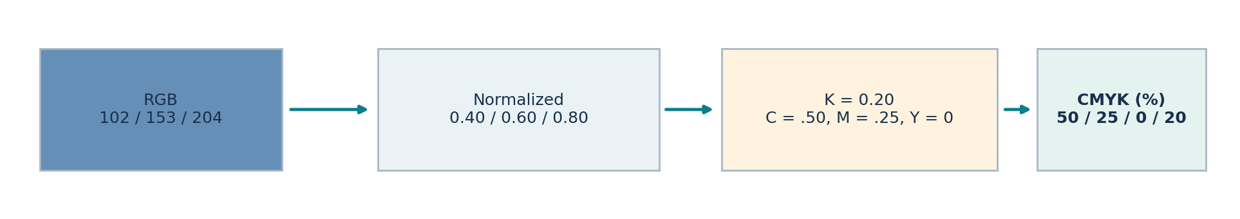

Complete worked example: RGB(102,153,204)
Normalize: Rₙ=102/255=.40; Gₙ=153/255=.60; Bₙ=204/255=.80.
K=1−max(.40,.60,.80)=1−.80=.20, so 1−K=.80.
C=(1−.40−.20)/.80=.40/.80=.50
M=(1−.60−.20)/.80=.20/.80=.25
Y=(1−.80−.20)/.80=0/.80=0
CMYK = (50%, 25%, 0%, 20%)

9. CMYK → RGB, special cases and verification

CMYK → RGB formula (idealized)
First convert every percentage to a fraction from 0 to 1. Then apply:
R = 255(1−C)(1−K)
G = 255(1−M)(1−K)
B = 255(1−Y)(1−K)

Complete example: CMYK(20%,40%,0%,10%)
C=.20, M=.40, Y=0, K=.10.
R=255(.80)(.90)=183.6 ≈ 184
G=255(.60)(.90)=137.7 ≈ 138
B=255(1.00)(.90)=229.5 ≈ 230
Answer: RGB ≈ (184,138,230)

How to cross-check RGB → CMYK → RGB
Take the earlier result C=.50, M=.25, Y=0, K=.20:
R=255(.50)(.80)=102; G=255(.75)(.80)=153; B=255(1)(.80)=204.
Recovered RGB = (102,153,204) ✓

Pure black and white exceptions
Input | CMYK outcome / explanation
RGB (0,0,0) | K=1, set C=M=Y=0 → (0%,0%,0%,100%)
RGB (255,255,255) | K=0, C=M=Y=0 → (0%,0%,0%,0%)
RGB (255,0,0) | K=0, C=0, M=1, Y=1 → (0%,100%,100%,0%)
RGB (128,128,128) | C=M=Y=0; K=1−128/255≈49.80%

Why divide by (1−K)?
CMY initially represents the complement of each normalized RGB channel. After assigning a common dark component K, the remaining coloured component must be rescaled by 1−K. For black K=1, this denominator is zero, so pure black is handled separately.

10. Formula sheet and teaching reminders
Task | Formula / decision
Slope | dx=x₂−x₁; dy=y₂−y₁; m=dy/dx when dx≠0
Shallow vs steep | Compare |dy| with |dx|, not just the sign of m
Line implicit form | F=dy(x−x₁)−dx(y−y₁)=0
Line sign for dx>0 | F>0 below; F<0 above; F=0 on the line
RGB → CMY | C=1−R/255; M=1−G/255; Y=1−B/255
CMY → RGB | R=255(1−C); G=255(1−M); B=255(1−Y)
RGB → CMYK | Normalize RGB; K=1−max; divide the other components by 1−K
CMYK → RGB | R=255(1−C)(1−K), etc.
RGB black | K=1 → CMY=0 as special case

Frequent student mistakes
- Using dy/dx when dx=0: vertical slope is undefined.
- Saying every negative slope is steep: use |dy| and |dx|.
- Confusing y-intercept b with the b coefficient of ax+by+c.
- Assuming the sign of F is fixed independently of coefficient scaling.
- Treating CMYK percentages as if they were RGB values between 0 and 255.
- Dividing by 1−K when K=1, which causes division by zero.
- Mixing up CMY complements with CMYK after adding K.
- Claiming idealized conversion gives exact real printer ink quantities.

Instructor delivery plan (approximately 90 minutes)
Minutes | Activity
0–15 | Explain slope, geometry, shallow/steep classification
15–35 | Derive implicit line in two ways and solve numeric examples
35–50 | Explain RGB and CMY/CMYK concepts with colour swatches
50–65 | Solve RGB-to-CMY examples
65–80 | Solve RGB-to-CMYK examples and show black special case
80–90 | Practice check + student questions

11. Student practice — questions only
Show all calculations. For conversion questions, report CMY/CMYK as percentages to two decimal places and 8-bit RGB outputs rounded to the nearest integer (.5 upward).
Q1. Calculate dx, dy and m for the line (4,2) to (12,6). Is it shallow or steep?
Q2. Calculate dx, dy and m for the line (5,10) to (8,1). Identify the direction and steep/shallow type.
Q3. Find the implicit line equation F(x,y)=0 through (1,4) and (9,8). Verify both endpoints.
Q4. Write an implicit equation for the vertical line through (6,−2) and (6,5). Explain why the slope is undefined.
Q5. For the line through (2,3) and (10,7), evaluate F(7,6) using F=dy(x−x₁)−dx(y−y₁). Is the point above, on or below the line?
Q6. List the RGB combinations for black, white, red, cyan and yellow (8-bit channels).
Q7. Convert RGB (30,100,220) to CMY percentages.
Q8. Convert CMY (10%,70%,40%) to 8-bit RGB.
Q9. Convert RGB (51,102,153) to CMYK percentages, showing normalization, K and C/M/Y.
Q10. Convert CMYK (10%,25%,40%,20%) to 8-bit RGB.
Q11. Convert RGB (0,0,0) to CMYK and explain how to avoid dividing by zero.
Q12. Explain in two sentences why RGB is additive while CMY/CMYK is subtractive, and why mathematical RGB-to-CMYK conversions may differ from a printer profile.
The instructor answer key starts on the next page. Student distribution can omit the answer-key pages.

12. Instructor answer key — mathematics

Q1. Slope and classification
dx=12−4=8, dy=6−2=4, m=4/8=.5. Because |dy|<|dx|, shallow positive.

Q2. Negative steep line
dx=8−5=3, dy=1−10=−9; m=−9/3=−3. Downward to the right; steep because |−9|>|3|.

Q3. Implicit equation
dx=9−1=8, dy=8−4=4.
F(x,y)=4(x−1)−8(y−4)=4x−8y+28=0
Check (1,4): 4−32+28=0; (9,8): 36−64+28=0. Equivalent simplified equation x−2y+7=0.

Q4. Vertical line
dx=6−6=0 and dy=5−(−2)=7. F=7(x−6)−0(y+2)=7x−42=0 → x=6. Slope is undefined because dx=0.

Q5. Implicit sign
dx=8,dy=4. F(7,6)=4(7−2)−8(6−3)=20−24=−4. With dx>0 and this F convention, negative means above the line. Check: y_line=.5(7)+2=5.5, and 6>5.5.

Q6. RGB values
Colour | RGB
Black | (0,0,0)
White | (255,255,255)
Red | (255,0,0)
Cyan | (0,255,255)
Yellow | (255,255,0)

Q7. RGB(30,100,220) → CMY
C=(255−30)/255=225/255≈88.24%; M=(255−100)/255=155/255≈60.78%; Y=(255−220)/255=35/255≈13.73%.

Q8. CMY(10%,70%,40%) → RGB
R=255(.90)=229.5→230; G=255(.30)=76.5→77; B=255(.60)=153. Answer (230,77,153).

13. Instructor answer key — CMYK and understanding

Q9. RGB(51,102,153) → CMYK
Normalize R=.20, G=.40, B=.60. K=1−.60=.40, so 1−K=.60.
C=(1−.20−.40)/.60=.40/.60=.666666…
M=(1−.40−.40)/.60=.20/.60=.333333…
Y=(1−.60−.40)/.60=0
CMYK ≈ (66.67%,33.33%,0%,40.00%)

Q10. CMYK(10%,25%,40%,20%) → RGB
Fractions: C=.10,M=.25,Y=.40,K=.20.
R=255(.90)(.80)=183.6→184
G=255(.75)(.80)=153.0→153
B=255(.60)(.80)=122.4→122
RGB ≈ (184,153,122)

Q11. Black case
RGB(0,0,0) → normalized (0,0,0). Then K=1−max(0,0,0)=1. The standard C/M/Y expressions have denominator 1−K=0. Set C=M=Y=0 directly. Result CMYK=(0%,0%,0%,100%).

Q12. Colour model concepts
RGB represents adding red, green and blue light from a display, whereas CMY/CMYK describes subtracting portions of reflected light using colourants on paper. Printer colour transformations use device/ink/paper profiles; simple formula conversions are only an idealized approximation.

Additional instructor oral checks
- How can a vertical line have an implicit equation even though its slope is undefined?
- If a line function is multiplied by −2, what happens to F>0 and F<0?
- Why is CMY (0,0,0) white while RGB (0,0,0) is black?
- Why must RGB be normalized before using the CMYK formulas?
- What is the result of CMYK (0,0,0,0)?
Suggested viva answers: implicit form handles dx=0; negative scaling reverses the sign; CMY denotes zero ink on white paper while RGB denotes zero light; normalization makes quantities compatible with 0–1 CMYK arithmetic; CMYK zero ink gives white substrate.

References / basis
AIUB Chapter 1 – Image Representation (source slides 15–28); AIUB Chapter 2 Part 1 – Scan Conversion (source slides 26–36). Supplementary worked mathematics and idealized CMYK conversions added for teaching.

